Golf Car
48V120AH

Battery Box Design Drawing
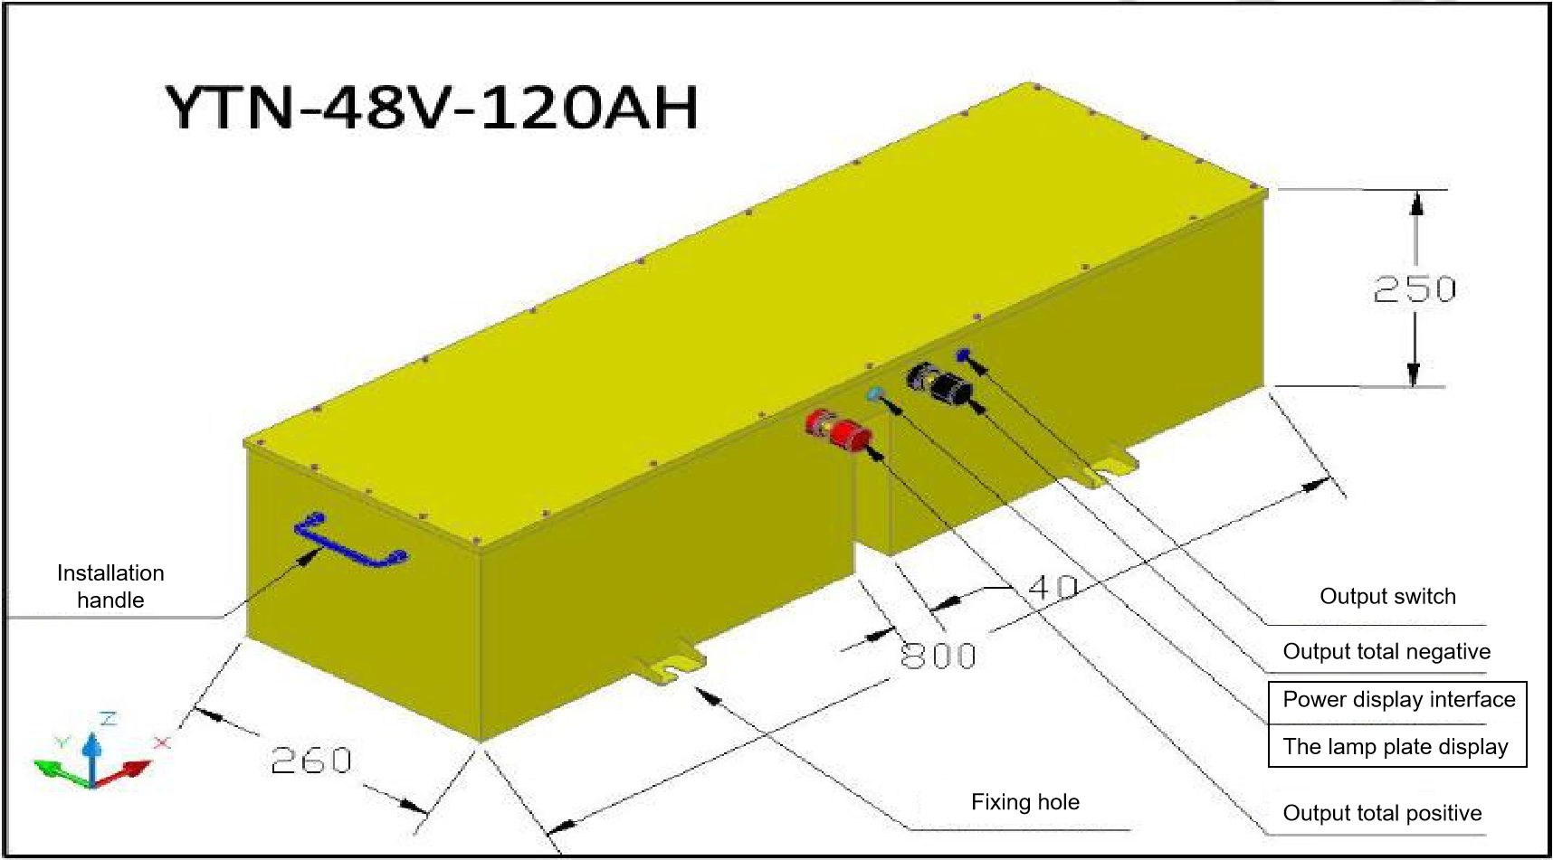
48V120AH Electric Wiring Diagram

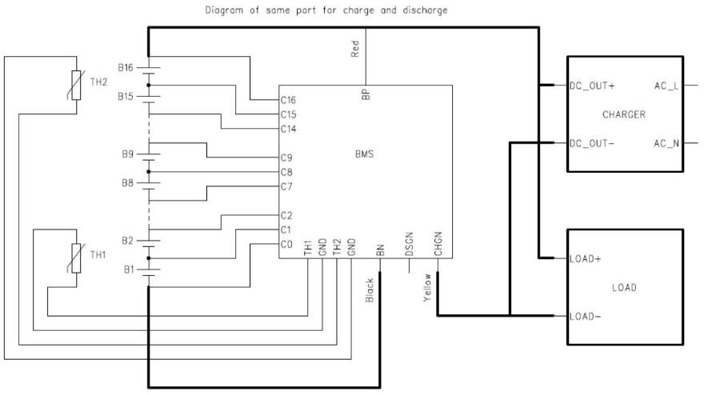

Battery Pack Parameters

Chemistry | LFP
Voltage/capacity | 48V/120AH
Weight | 55kg
Working temp | -20 °C ~60°C
Max charge current | 100A Max 100A
Max discharge current | 100A Max 100A
Ingress Protection | IP65
Battery cycle | >2000 cycles
Heat function | No
Communication | RS485
Other | SOC LED

